Making an Easter Garden

An Easter Garden is one way to help us remember what happened at Easter – that Jesus was crucified and died on Good Friday and that he rose from the dead on Easter Sunday.
You need to include these 2 elements in your garden – a hill with 3 crosses and a tomb with the entrance covered with a stone.
Your garden can also include other aspects of the story – soldiers, an angel, Mary Magdalene and Jesus.
You can make your garden as simple or as decorative as you like, depending on what you have at home.
If you don’t have a garden outside for soil or plants, you can make one with scrunched up paper to make the hill, crosses and stones from card and flowers from paper.

You will need:
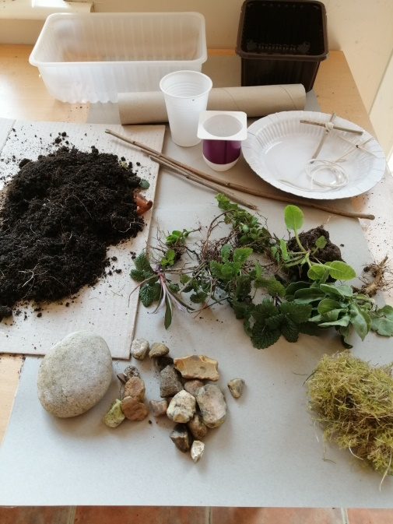 | A container – a food carton, paper plate, plastic bowl or garden tray  Cocktail sticks, lolly sticks or twigs and thread or string to make 3 crosses  A small pot or yoghurt pot or section of kitchen or toilet roll for the tomb  One large stone and several small stones or pebbles  Garden soil or compost  Little plants from your garden or you could make flowers from card or paper  Moss, grass (you could plant seeds if you have some) or sand  A trowel or spoon

What to do:
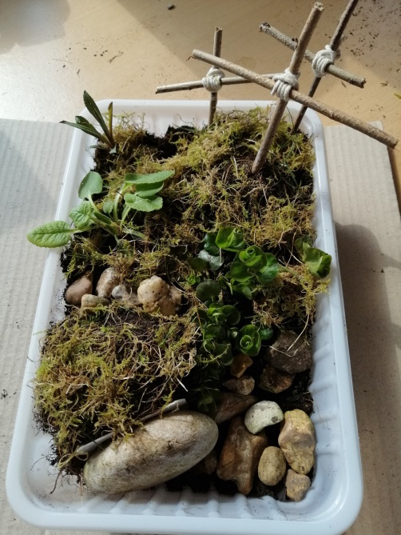 | Fill the back half the container with soil to make a hill.  Put in the plants with the trowel or spoon making sure the roots are covered.  Plant in the grass or sow your grass seed.  Place the pot or kitchen roll piece near the front and cover the ‘tomb’ with soil.  Put the big stone in front.  Arrange the other little stones around the front.  If you are using moss or sand, cover the garden now.  Water the soil gently.  Make 3 crosses with sticks or twigs and thread or string  On Good Friday push the crosses into the hill to show that Jesus was crucified.  On Easter Sunday roll the stone away from the tomb to show that He had risen from the dead.

If you want to read the story of Easter, read from Luke chapter 22 verse 47 to chapter 24 verse 12.

